**DAILY ONLINE ACTIVITIES SUMMARY**

|  |  |  |  |  |  |  |  |  |
| --- | --- | --- | --- | --- | --- | --- | --- | --- |
| **Date:** | **20/05/2020** | | | | | **Name:** | **Archana J C** | |
| **Sem & Sec** | **4th Sem , A** | | | | | **USN:** | **4AL18CS011** | |
| **Online Test Summary** | | | | | | | | |
| **Subject** | | **Complex analysis, Probability distribution and statistical methods** | | | | | | |
| **Max. Marks** | | **45** | | **Score** | | | **-** | |
| **Certification Course Summary** | | | | | | | | |
| **Course** | **Introduction to R** | | | | | | | |
| **Certificate Provider** | | | **Great learning academy** | | **Duration** | | | **3 hours** |
| **Coding Challenges** | | | | | | | | |
| 1. **Write a Java program to find the Nth natural number with exactly two bits set.** | | | | | | | | |
| **Status: Completed** | | | | | | | | |
| **Uploaded the report in Github** | | | | | **Yes** | | | |
| **If yes Repository name** | | | | | **https://github.com/alvas-education-foundation/archana_j_c** | | | |
| **Uploaded the report in slack** | | | | | **Yes** | | | |

Online Test Details: (Attach the snapshot and briefly write the report for the same)

Certification Course Details: (Attach the snapshot and briefly write the report for the same)

Coding Challenges Details: (Attach the snapshot and briefly write the report for the same)

ONLINE TEST : The test is from **Complex analysis, Probability distribution and statistical methods, which is from module 1. The time given was 45 minutes.** The test was good . it was easy . No issues faced.

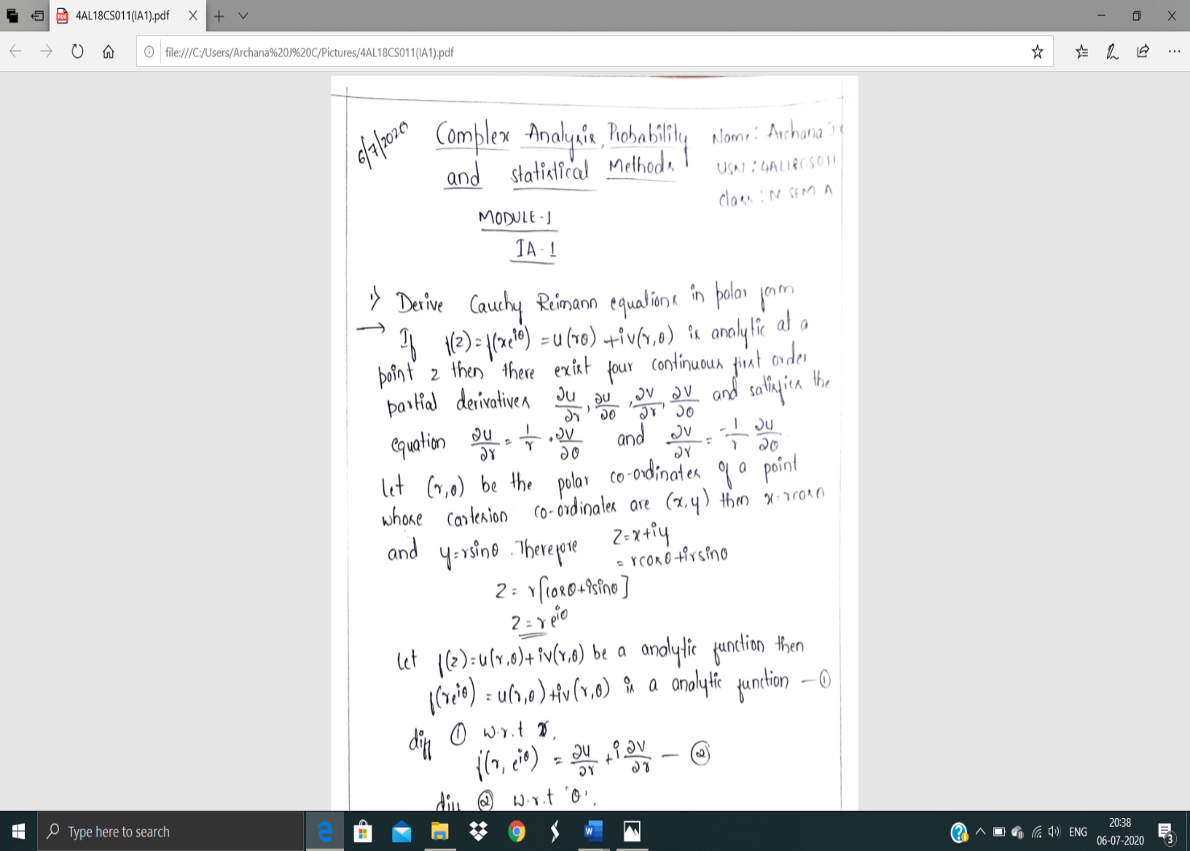

ONLINE CERTIFICATION COURSE : I’m doing Introduction to R course , which held by great learning academy . Which s about 3 hours course.

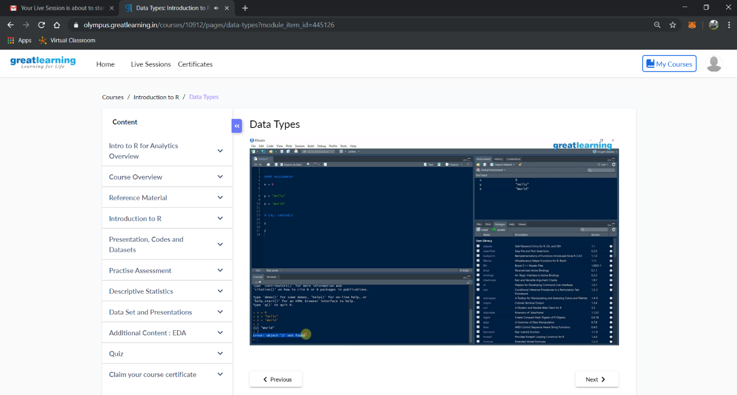

Coding Challenges Details: (Attach the snapshot and briefly write the report for the same)

Today I’m done with some java programs. The solution are already uploaded in github repository.

Program : Write a Java program to find the Nth natural number with exactly two bits set.

